Water security in the trilemma of the water pricing policy, the social function of water, and the treats to water resources in Thailand [Fonts: Cambria Math bold 16 pts]
AS Permana¹, S As’ad², A Petchsasithon³, C Ikhsan⁴ [Fonts: Cambria Math 12 pts]
¹Email: author1@kmitl.ac.th, School of Engineering, KMITL [Fonts: Cambria Math 10 pts]
²Email: author2@ft.uns.ac.id, Faculty of Engineering, UNS
³Email: author3@kmitl.ac.th, School of Engineering, KMITL
⁴Email: author4@ft.uns.ac.id, Faculty of Engineering, UNS

Innovative Engineering and Sustainability
Journal Homepage: https://iesj.ft.uns.ac.id
Article ID: XXX

ARTICLE HISTORY
A B S T R A C T

Received: 12 September 2020
Received in Revised Form: 2 December 2020
Published Online: 2 January 2021.
Keywords: water-pricing policy, social function of water, water demand and supply;

DOI:
The water security issue is worsened by the presence of the global threat of climate change that may inhibit the global and local water availability. This study explores the water security from the perspective of three impelling factors, and was carried out in Bangkok Metropolitan Region (BMR), Thailand. We define the trilemma a three generally conflicting factors that brings different consequences in view of the water security. The study was organized by accounting time-independent hydrological budget in the region comprises of surface water, probable atmospheric water, and groundwater against current and future water demand with particular water qualities for different purposes. A sensitivity analysis has also been done. The study found that with current water resources development and water demand, the BMR would unlikely encounter the water security issues, given the existing trilemma as constraints. However, with continuous increase of water demand and unchanged supply, the water scarcity would likely be faced by BMR, as analysis suggests.

[NOTE]: Abstract should, at least, contain the following items: (1) background of the study (2) objectives and aims (3) methodology (4) outputs, outcomes or results of the study (5) conclusions and way forward. [Fonts: Cambria Math 10 pts, maximum word counts: 200].

1 Introduction [Numbered, Cambria Math Bold 12 pts]

[Cambira Math 11 pts] Water is the most important element in life. There is almost no life without water: for example, many astrophysicists, astrobiologists and scientists agree that evidence of life on Mars can be seen in the presence of water on this red planet. We can live without food for 20 to 30 days or even more, but we can live without water for 3 to 5 days only. Thus, water is an essential component of life (Ghose, 2015; Westall & Brack, 2018). Water must therefore be safeguarded for maximum use by people. In line with this, Jiang (2015) stated that water availability is facing challenges, due to a more unbalanced geographic distribution, decreasing water quality and therefore augmenting the scarcity of water (Jiang 2015; Mancosu, et al., 2015). Increasing water demand, caused by development and population growth, adds to the water security challenges (Iglesias, 2007; Zeitoun, Lankford, Krueger et al., 2016). Thus, there remains a constant threat to water resources for many reasons (Collins & Bolin, 2007; Giordano & Shah, 2014). Because of the importance and broad spectrum of water use, water issues may generate a multi-lateral dilemma, on natural and anthropological concerns, which may also cause detriment to the people or the water itself.

Despite small percentage of fresh water on earth and the total quantity of water is constant, there is a constant and consistent decreasing of water quality (Misaghi et al., 2017). One of the consequences of this issue is unswerving increase of the price of water. This issue has been exacerbated with imbalanced and unequal geographical distribution of water that leads to water security and water accessibility (He et al., 2018). From the perspective of southeast Asian countries, where the study area is located, the issue is rather associated with water management than unequal distribution of the surface water, since the region has been blessed with abundant water resources. The low capacity of water management may lead to water security issue (Cook & Bakker, 2012; Cosgrove and Loucks, 2015; Penn, Loring & Schnabel, 2017). It has been quite sometimes the water security issue taking place in the region. It is therefore becoming an interesting research arena.

We scrutinized water security issues, within the context of a trilemma, i.e. a problem with three generally conflicting elements. This trilemma, shown in Figure 1, includes water pricing policy that represents the economic side as the first element of the triangle, the social function of water that characterizes the social entity as the second element, in which both are within anthropological discipline, and the third lemma is the threats to water resources, which epitomizes the natural part of the natural-anthropological interaction. The trilemma in Figure 1 shows the possibility of either positive or negative consequences within the context of interconnections between its elements. Positive consequences strengthened the situation whereas negative ones undermine it; the fallouts are depending on the strength of one element against another element. For example, between water-pricing policy (element 1) and threats to water resources (element 3), if the water-pricing policy prevails, i.e. if the budget for the maintenance of water resources is sufficient, as a result of the works of water-pricing policy, the threat to water resources can be minimized, as environmental devastation to water resources can be controlled. Alternatively, if threats to resources (element 3), prevail, higher water prices must be imposed. Through these conflicts, the trilemma of water security in Bangkok Metropolitan Region is assessed in this paper.
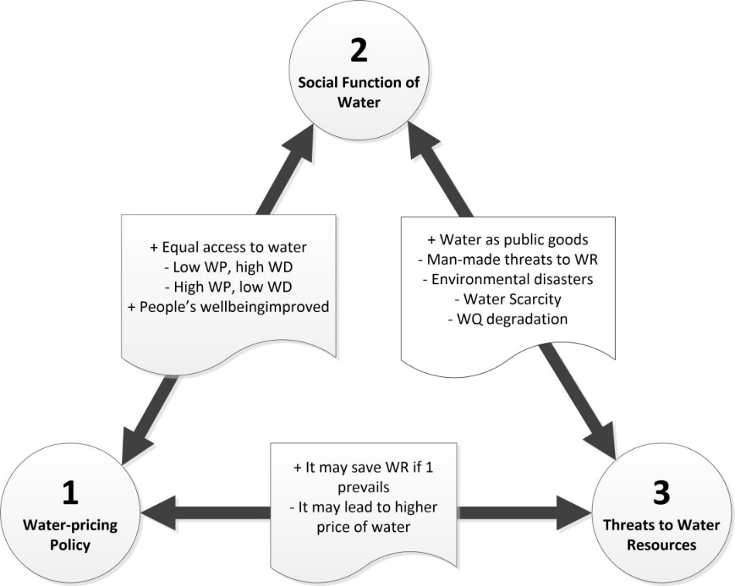

Figure 1 [Cambria Math Bold, 11 pts]: The Trilemma: A Problem with Three Conflicting Aspects [Cambria Math, 11 pts]
NOTE: WP: Water price, WD: Water demand, WR: Water resources, WQ: Water quality [Cambria Math, 9 pts]

Climate change is considered one of the culprits in water security issues. Its manifestation may have shifted the rainfall trends in a region that alters it from wetter to drier or vice versa (Eionet, 2018; Eekhout et al., 2018). Waterfootprint, (2019) and Hirmas et al. (2018) have also warned that climate change will disrupt local and global water cycles, which will change water availability at local and regional levels. By these notions, the impact of climate change on water resources availability is certain and imminent, as climate change is understood to have been undergoing for decades. The industrial revolution era is believed as one of the milestones of climate change (Albritton-Jonsson, 2012; Baer, 2012). While this perspective sees the water availability from the quantity viewpoint, the water availability should ensure that the available water is in acceptable quality. By this, the existing quality of water ensures the economic viability of the water treatment cost towards consumable water for different purposes.

Pereira et al., (2009); Kisakye and Van der Bruggen (2018) asserted that from the standpoints of either local or global water balance, the issues of water security can be seen in clearer picture from the supply and demand sides, which takes account of water scarcity with respect to extent, distribution, and quality of water. The falling of the quantity and quality of water as a result of various reasons might enhance the insecurity of water for utilization (Mekonnen, 2010; Van Beek, et al., 2011). The water becomes scarcer geographically across a region and the quality of water plummets and making the cost of water treatment higher and therefore the water price higher, and this is a social injustice of water for the people (Aschner et al., 2021; McIntyre-Mills, 2018; Carr, Seekell & D’odorico, 2015). The approach to cope with the issues in water security should deliberate both demand and supply sides. In terms of supply side, the quantity of supply is dictated by limiting natural factors of geography, hydrology, environment, and disaster, as the water is a natural element. The choice is therefore not unlimited. By this limiting factor and the extent of impacts of water security, a comprehensive approach to deal with the water security issues would be indispensable.

Thailand, Bangkok Metropolitan Region in particular, has been experiencing many water catastrophes driven by prolonged drought and increasing water salinity in the Chao Phraya River, the only water resources for Bangkok City’s water supply system that makes the water availability reduced (Molle et al., 2000). Now, the water crisis seems more frequent, and it may also indicate the issue of water security and scarcity for Bangkok City and the surrounding provinces, which is politically called Bangkok Metropolitan Region (BMR). Looking at the extent of social, physical and economic impacts of the drought as a water security issue in Thailand, as illustrated in Table 1, a study on water security within the context of trilemma is a plausible research arena.

Table 1: [Cambria Math Bold, 11 pts] Extent of Impacts of Drought in Thailand [Cambria Math, 11 pts]

Year | Number of affected provinces | Extent of impacts
 |  | People affected (1000) | Affected agricultural area (km²) | Approximate economic losses (1000 USD)
2007 | 66 | 16,754 | 540,047 | 6,109
2008 | 61 | 13,298 | 209,999 | 3,200
2009 | 62 | 17,353 | 237,773 | 3,337
2010 | 64 | 15,740 | 686,741 | 43,598
2011 | 55 | 16,560 | 324,672 | 4,062
2012 | 52 | 15,234 | 594,604 | 12,297
2013 | 58 | 9,066 | 1,708,918 | 89,802
2014 | 53 | 16,024 | 474,330 | 62,654
2015/2016 | 48 | 11,003 | 1,344,253 | 72,240
2016/2017 | 50 | 12,532 | 168,541 | 55,220
2017/2018 | 51 | 13,780 | 197,684 | 124,332
2018/2019 | 53 | 14,486 | 331,368 | 316,742
Sources: Royal Thai Department of Disaster Prevention and Mitigation (2015); Economic Intelligence Center, SCB (2016); NNT (2019); Manorom (2020). [Cambria Math, 9 pts]

Bangkok Metropolitan Region (BMR) refers to a political definition of the urban region surrounding the administrative boundary of metropolis of Bangkok. It is an urban agglomeration of Bangkok, the Capital City of Thailand, with the five adjacent provinces of Nakhon Pathom, Pathum Thani, Nonthaburi, Samut Prakan and Samut Sakhon - see Figure 2. The Bangkok Metropolitan Region was selected for the study because it often experiences severe drought as well as its strategic position as the capital city of Thailand and its important hinterlands. By reason of this position, the region should have not been suffered from the severe impacts of droughts.
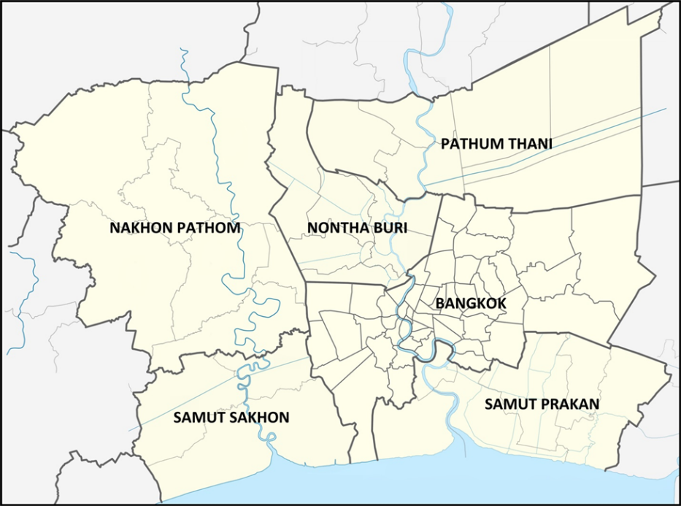

Figure 2: Bangkok Metropolitan Region: Bangkok and Five Surrounding Provinces

2 Objectives and Methodology

The study explored the intertwine factors determining the water security in Bangkok Metropolitan, and five neighboring provinces, those are Pathumthani, Nonthaburi, Nakhon Pathom, Samut Sakhon and Samut Prakan, known as Bangkok Metropolitan Region. Despite numerous aspects of water security, the study focuses only on intertwining of the three essential factors influencing the water security. They are water pricing policy, the social function of water, and the imminent threats to water resources in the Bangkok Metropolitan Region. The elements within the intertwinement may either reinforce or weaken one another in the water security outlooks in the region. The study was undertaken by examining the water resources data of Thailand and BMR during the period of 1983-2016, with respect to average data of monthly and annual rainfall, monthly evapotranspiration, groundwater storage across Thailand, the data water consumption for domestics, agriculture and industry, and the historical extent of the impacts of drought on agriculture and economics. The study also examined the water pricing policy, and the possible environmental threats to water resources that may lead to the devastation of the resources, and intimidates its functions to serve the consumers.

In evaluating the water availability in the region, the study employs generic time-independent hydrologic budget model in which the time period is taken as the time-scale of one-cycle of the hydrologic season in the region, normally one year. The generic time-independent hydrologic budget model is expressed in the following equation:

$$∆S=P-R-G-E-T$$

Where $∆S$: regional storage of water
$P$: regional precipitation depth within one cycle of hydrologic season
$R$: regional surface runoff
$G$: regional percolation to groundwater
$E$: regional evaporation
$T$: regional transpiration

The variables that may not be appropriate to be taken at regional level such as runoff coefficient, the value is taken from the locally derived quantity and take the average that suitably represents the regional level. Any other variables above are appropriate to be taken at regional level.

3 Water resources potentials in Thailand

Annual water potential of a region is estimated from the area of the region, average annual rainfall depth, potential groundwater storage, and potential evapotranspiration. This water potential assumes that each element of water resources is considered independent one another. This is to simplify the interconnection among the element of water resources as inter-elemental water transfers are unknown and the data itself has been found independently, and most importantly the estimation of water balance is time-independent. By this assumption, the water balance can be estimated as shown in Table 2. The data for the analysis of water balance as shown by the table is based on the water resources data during the period of 1983-2016. However, for the practical purpose, the table shows only summary of the information for the period of 2000-2016 with some important elements.

Table 2: Annual Water Potential and Use in Thailand and BMR, 2000-2016

Year | Water Potential (10⁹ m³/year) |  | Water Use (10⁹ m³/year) |  | Balance (10⁹ m³/year)
 | Thailand | BMR | Thailand | BMR | Thailand | BMR
2000 | 916.95 | 13.87 | 68.51 | 1.04 | 848.43 | 12.83
2001 | 863.07 | 13.05 | 68.38 | 1.03 | 794.69 | 12.02
2002 | 804.57 | 12.17 | 68.26 | 1.03 | 736.31 | 11.14
2003 | 685.02 | 10.36 | 68.16 | 1.03 | 616.85 | 9.33
2004 | 645.50 | 9.76 | 68.08 | 1.03 | 577.43 | 8.73
2005 | 666.03 | 10.07 | 68.01 | 1.03 | 598.02 | 9.05
2006 | 826.12 | 12.50 | 67.96 | 1.03 | 758.16 | 11.47
2007 | 707.59 | 10.70 | 67.93 | 1.03 | 639.67 | 9.68
2008 | 782.51 | 11.84 | 67.91 | 1.03 | 714.60 | 10.81
2009 | 825.10 | 12.48 | 67.91 | 1.03 | 757.19 | 11.45
2010 | 860.50 | 13.02 | 67.93 | 1.03 | 792.58 | 11.99
2011 | 890.78 | 13.47 | 67.99 | 1.03 | 822.79 | 12.45
2012 | 887.70 | 13.43 | 67.75 | 1.02 | 819.95 | 12.40
2013 | 904.63 | 13.68 | 67.51 | 1.02 | 837.12 | 12.66
2014 | 805.60 | 12.19 | 67.57 | 1.02 | 738.03 | 11.16
2015 | 733.76 | 11.10 | 67.63 | 1.02 | 666.14 | 10.08
2016 | 695.28 | 10.52 | 67.69 | 1.02 | 627.59 | 9.49

NOTE: Water use consists of domestic use, industry, agriculture, and maintenance flow for ecological preservation (the consumed use of water), the non-consuming use e.g. hydropower is not included in the consumption.

Based on water potential, the table shows that none in any year Thailand or BMR suffers from water shortage as the balance shows all positive figures. However, the fact shows that Thailand or BMR experienced many water scarcities. This is most probably because of the following reasons: (1) the data of water balance is temporal and spatial independent i.e. ‘annual’ and ‘in Thailand or BMR’; meanwhile, the water shortage can be any time in a year (2) while the water potential is a gross state, the usable water (the net state) might be far below the quantity of water potential (3) it shows the efficiency of water management level in Thailand or BMR i.e. too much water is left unutilized particularly during the rainy season, for instance, the total volume of existing reservoirs in Thailand could not store all obtainable water potential, (4) The supply side is a ‘potential’ figures, which is the theoretical availability of the water, and it is completely different with ‘available’ figures. It requires strong efforts to convert the potential water to available water, for example to dam constructions. At the same time, not many suitable sites of reservoirs are available in Thailand, and the resistance from the pressure groups who opposed the development of large dams, because of the environmental and ecological issues. If Thailand could maximize the usability of potential water towards one-hundred percent, the water security could be locked and flooding problems could be largely controlled except flooding caused by local drainage problems in urban areas, particularly Bangkok and the surroundings. Our estimate shows that current capacity of reservoirs in Thailand is about 15% to 20% of the ideal capacity to control most potential runoff.

4 The Trilemma [level 1 - Cambria Math Bold, 12 pts]

4.1 Water-pricing Policy in Thailand [level 2 – Cambria Math Bold, 11 pts]

National Water Resources Commission (NWRC) ex-officio chaired by the Prime Minister of Thailand, with the members comprises of ministers concerned with water resources, and others agencies, is in-charge of overall water resources management in the country including the formulation of water pricing policy. On the water pricing matter, Thailand applies different bulk water pricing system for different water use and quality of water i.e. treated water for domestic purposes is different with untreated raw water for agriculture purposes. The tariff is basically based on volumetric use i.e. m³. For example, treated water (drinking water) produced and managed by Provincial Waterworks Authority (PWA) and Metropolitan Waterworks Authority (MWA) is differentiated from the water tariff of irrigation and industry, which requires lower water quality in comparison to drinking water, and thus the tariff, is much cheaper than drinking water. Tariff differentiation is also applied across the users of drinking water, e.g. residential, government agencies and business. The residential user is certainly cheaper than business users. For the bulk water pricing system, water tariff for irrigation is certainly cheaper than water tariff for industry. Also, the tariff of drinking water applies progressive water price. Higher unit price of water is applied for higher consumption. This is good to encourage water saving and efficiency.

Thailand’s Water Resources Act (WRA) 2018 does not specifically provide guidance on how to determine water tariff. However, looking at the fact that water is public goods (Chapter II Section 7 of WRA 2018), in which the property rights is assigned to the government (Chapter I Section 6 of WRA 2018), the water price in Thailand might basically be determined per general formula of:

$Water price ∝function \left\{Cost recovery, marginal benefit\right\}$ … Equation [1]

where:

Cost recovery considers the expenditure of the infrastructure development;
Marginal benefit includes operational costs of the company, development costs, ecological preservation, and corporate social responsibility.

Current drinking water price is THB 10-21 (USD 0.32-0.68) per m³ for residential use, depending on the consumption, progressive water price applies. For government agencies and small business, the price of water is THB 17-28 (USD 0.55-0.90) per m³, the same rule applies. For state enterprises and large business, the price is THB 18-32 (USD 0.58-1.03) per m³. The price of non-drinking water is currently free or in other word it is subsidized by the government. However, invoking Section 43 and 47 of WRA 2018, the government through NWRC has proposed to remove this subsidy by introducing water use fee, even though some academics opposed this proposal. The proposed fee is THB 1-3 (USD 0.032-0.096) per m³ bulk raw water, depending on the type of consumption and the scale of consumers. Small-scale farming system would pay less than large-scale farming system. Tourism industry would pay less than large-scale power generation.

The introduction of water use fee of the non-drinking water users by the government is to transfer the liability of cost recovery for irrigation and water resources infrastructure from the government to the users (see the above water price function). It is acceptable from traditional market economy for sustainable water resources development in Thailand amid shifting the development paradigm from agriculture to industry. In this case, the government’s expenditure must now be focused more on the development of industries, at the same time agriculture development is shared between the government and the farmers. However, there are disagreements on this proposal for some reasons: (1) it would impoverish the farmers by adding the water use fee into their expenditure, which have already been very much loaded by many expenses (2) unlike drinking water, it would be difficult to measure the use of bulk water for irrigation, including monitoring of the water use (3) there is no guarantee of water availability once farmers need to irrigate the plants unless with agreeable scheduling.

In Thailand, there are two types of water price: bulk raw (untreated) water for irrigation (agriculture), industrial, and other purposes, and treated water for domestic (water supply) purposes. Generally, people at large are not directly involved in the formulation of water pricing policy. However, people can voice their concerns through submitting the petition to the government, or through other channels. This is particularly applicable when determining the price of raw water for irrigation or agriculture water. For the domestic water, on the other hand, the water price is determined by the company i.e. Metropolitan Waterworks Authority (MWA) or Provincial Waterworks Authority (PWA) under the Ministry of Home Affairs, Kingdom of Thailand. The exercise by MWA or PWA in determining the water price largely applied the price based on the above formula. During the period of exercise, people may submit the objection or opposition on the proposed water price to the authority. Due to the nature of the MWA or PWA, the economic consideration may supersede social deliberation. The price of treated water is therefore predominantly determined by economic consideration.

4.2 Social Function of Water [level 2 – Cambria Math bold, 11 pts]

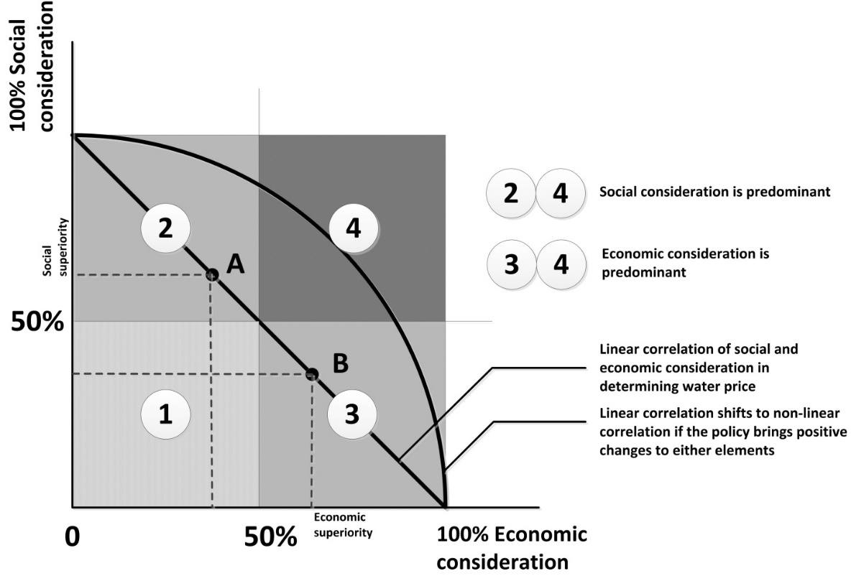
Section 7 Chapter II of WRA 2018 asserts that water is public goods. The term of public goods implies that the goods belong to public at large, and it must therefore be used for the maximum benefits of the Thai people. The unique position of water has made water a strategic object and created multilateral lemma. Making the water a fully commercial commodity would not be appropriate for time being, in view of the socio-economic conditions of the country and people. The mere social consideration in defining social function of water may not workable in overall. The social function of water resources requires holistic approach in dealing with the interaction between water and people (Bonnal, 2003). People, the major stakeholder of the country must be given a significant role in formulating water-associated policies, in a bottom-up policy-making system. This process is supposed to be mainstreamed in the law to ensure that the involvement of stakeholders is secured. By this process, one of the wings of social values is upheld.

Figure 3: Social Value vis-a-vis Economic Value of Water

Water contains economic and social values. It depends on the authority, owner or manager of the water, to which direction the value is emphasized. The economic and social value of water, to some extent, can be said as a ‘zero-sum game’. In this case, the economic value of water increases at the cost of the decrease of social value or vice-versa. In fact, however, this correlation is not linear and straightforward as the increase of price of water, for instance, would increase the revenue of the water authority, owner, manager, or company, and if the increase of revenue is to be invested for the promotion and alleviation of the socio-economic status of the public at large, then the linear correlation of economic value and social value of water is invalid. The illustration of the correlation between economic value and social value of the water is shown in Figure 3.

Figure 3 shows that there are theoretically four regions that show different emphasis of the water-pricing policy. The regions are basically the superior-inferior or dominant-subservient correlation of social and economic elements. These four regions could be simplified into only two regions of superior-inferior correlation, in which the boundary between superior and inferior is fifty percent of superior or fifty percent of inferior or at the middle of the two ends. The Figure shows that the region 2 and 4 represent the superiority of social value and accordingly the region 3 and region 4 represent the superiority of economic value during the formulation of water-pricing policy. The diagonal line shows the correlation between social consideration and economic consideration. At any point along this line, the superior/inferior element is expressed. For example, point A shows social consideration is superior upon economic consideration, and point B shows the inferiority of social consideration. There is no rule of thumb to determine at which point the optimum point is accomplished. The decision depends upon the condition at a particular time and the water authority itself. As guidance, however, social superiority could be taken when the socio-economic condition of the people/consumer is at under-developed stage. On the other hand, the economic consideration takes precedence over social consideration when the socio-economic level of the people is at developed phase.

Within the context of social function of the water, social consideration in determining the water price is supposed to be superior in comparison to economic consideration. Thus, while the price of water must be affordable for most of the consumers, the price of water at this level must also be able to offer benefits to the producers, and offer the ability to improve the services. By this interaction, the sustainability of water supply services could be guaranteed.

4.3 The Threats to Water Resources Development and Management

Water resource is embedded in and as a fundamental part of the natural environment, and it thus receives the threat from the external forces in line with the hazards to the environment. If the environment is devastated by the external force, the water resources would also be shattered and slowdown or totally stop in providing the services to the people. The impacts could be in terms of reduction of raw water quality that leads to the increase of water treatment costs, and therefore the water price. Another threat would likely come from anthropogenic activities that lead to water quality degradation amid increasing competitive use of water (Engle et al., 2011). While quality of water is continuously degrading due to a number of natural and anthropogenic causes, the number of water users is steadily increasing, making the competing use of water higher and water becomes more economic goods leaving the social function of water behind.

The water quality degradation due to natural or man-made disasters causes the cost of water treatment higher and consequently water price is higher. This is a logic correlation between social function of water, threats to water resources and price of water. Moreover, the threats to water resources development and management are also the direct peril of mankind as a whole as every single person is basically a water user. Another very important emerging global issue that threats to the presence of water, with respect to geographical distribution of water, usable and distributable water is climate change. Climate change may create a global catastrophe in terms of either water scarcity i.e. prolonged droughts or over-abundance of water i.e. floods.

Thailand has lengthy experience on both droughts and floods that lead to water-associated disasters, which impacted both people and the water resource itself. The disasters would influence the normal capacity of water supply in spite of increasing demand, and thus triggering water scarcity, which can also be considered as another water-associated disaster. The coping strategies to deal with the water scarcity in Thailand that makes Thailand more resistance to droughts may basically comprise of (1) maximizing water storage (2) maximizing the efficiency of water allocation (3) inter-basin transfer to cope with geographical disparities of water availability (4) optimizing the conjunctive use of surface and groundwater (5) optimizing the planting seasons (6) minimizing the leakages. Managing water scarcity is, in principle, much harder than managing water excess, since people cannot create water.

The interplay among the elements of the trilemma can be illustrated with a meek linear correlation with respect to socio-economic aspect of the people, as reflected in the water price, as shown in Figure 4. The Figure shows three axes of Water-Pricing Policy, Social Functions of Water, and Threats to Water Resources. The arrow of each element shows the direction of the elements towards the maximum emphasis of the element, for instance the prevailing economic consideration over other considerations on water-pricing policy is reflected in the direction of the arrow from zero (0) to positive (+) direction. The direction of ‘wedge’ from lower to higher in parallel with the direction of arrow shows that the water price is higher. In contrast, the concern of social function of water in determining the water price, will lead to lower water price as reflected in the ‘wedge’ of Social Functions of Water. Similarly, the higher threats to water resources will cause the higher water price as water-associated disasters likely occurred. The higher water price is exhibited in the wedge is higher at positive direction.

The three axes show the two elements of water pricing policy and threats to water resources are in the same direction and the elements are in constructive interference, that is, as the element moves toward positive direction, the price of water will be higher. On the other hand, one element of social functions of water moves toward opposite direction, that is, as the emphasis is given to this element in determining the water price, the price of water is lower. From the trilemma, the issue can then be simplified into only the dilemma between water pricing policy and threats to water resources on one end, with social function of water on the other end of the dilemma. However, while the one end of the issue presents two elements and the other end present only one element. The dilemma would likely be leaned in the direction of higher water price. It is logic as the threats to water resources will require financial support to cope with it, and it will give burden to current revenue of the water company and consequently influence the determinant of water price.
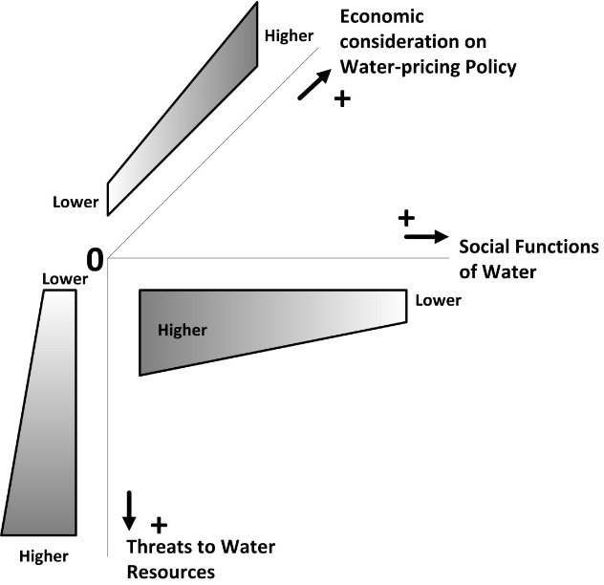

Figure 4: Correlation of Trilemma Elements in terms of Water Price

The global water quantity is theoretically constant on earth, although each country, depending on geographical and geological conditions, has different water potential. Furthermore, the quantity of fresh water is only a very small fraction of the global water, and the extent of readily available fresh water is even smaller and shrinking over time. The insignificant quantity of fresh water globally, the steadily decreasing water quality of water, due to various factors, continuous population growth and climate changes that have negative impacts on water resources, worsens the situation. It is, therefore, hard to maintain water as “social goods”. A shift of water to become an economic commodity cannot be avoided sooner or later. In Thailand, water has not yet transformed fully from “social goods” to become an economic commodity. As an illustration, the price of tap water, provided by PWA and MWA, is typically around USD 0.5/m³ (depending on the type of users and consumption, the water cost range is between USD 0.32 to 0.68 per m³), and the price of mineral water, produced by a fully profit-oriented private company, is USD 380/m³ . The price of water with ‘social function of water’, as reflected by the water price as determined by PWA and MWA is far below the price of ‘fully economic motive’ treated water produced by private company, and it shows the clear presence of ‘social function of water’. The current water price of piped water managed by PWA and MWA is very much considering the social function of the water.

Considering factors determining the water-pricing as exhibited by equation [1], and socio-economic consideration as demonstrated by figure [3], the correlation among trilemma elements as shown in figure [4], the water-pricing system is a complex decision towards the optimal water price, which is sustainable in view of socio-economic and environmental aspects. Depending on prevailing preference of the policy makers, the ambiguous water pricing in Thailand may be expressed in two forms of objective functions, which are either maximizing the benefit of the water service provider towards sustainable water resources management i.e. water security included, or minimizing the water price itself with the goal is to maximize the water service to as many as citizens.

With respect to maximizing the benefit, in which economic consideration takes precedence over social consideration, the optimization may be expressed in the following objective function:

$Maximize Total Benefits=\sum_{T=360}{\left\{\left(V_{T}×WP\right)-O-E-D\right\}}$ [1]

Subject to
$V_{T}≥LOS×POP$
$WP=\left(w×SOC\right)+\left(1-w\right)×ECO$
$O, E, D:constants along the period$

Where: $V_{T}:Volume of water availability at T$
$WP:Price of water$
$O:Operational costs$
$E:Environmental costs$
$D:Development costs$
$w:weighting factor of Society \left(SOC\right)and Economic (ECO)$
$LOS:Level of Services$
$POP:Number of population$

The other way to state the objective function is to minimize the price of water. In this case, the social consideration is superior over economic consideration. The objective function of socialistic approach is stated as:

$Minimize Water Price=\left(w×SOC\right)+(1-w)×ECO$ [2]
Subject to
$w≥0.60$
$SOC≥E$
$ECO≥O+D$

The decision makers may select these ambiguous approaches in determining the price of water that suits the regional condition. The common ground of these two approaches is both promoting water security and environmental sustainability.

The current water price in Thailand is perhaps demonstrating these two approaches, as reflected in dual water price system. The different situation does exist on the price of water for irrigation and agriculture purposes, as the water quality of drinking water and irrigation water is completely different. While the drinking water is treated water, the irrigation water is raw water. It must therefore be distinguished. The price of water for irrigation could not be fully commercialized with full consideration on economic and profit motives.

4.4 The Trilemma and Water Security Situation

By employing time-independent hydrologic budget in the region, we examined the national water balance of Thailand (as illustrated in Figure 5) and Bangkok Metropolitan Region (Figure 6), regardless the more specific temporal and spatial distribution of the water, it shows the water surplus of water based on monthly water status overall. On the other hand, still both Thailand and Bangkok Metropolitan Region are experiencing water insecurity issues, particularly drought that brings socio-economic losses to the country and the region.

Based on Thailand’s water resources data 1983-2016, the water status can be summarized in Figures 5 and 6. These figures exhibit the water availability, which is basically the amount of water made available at present level of water management of the water authorities. The fresh water potential in Thailand is actually much larger than the water availability. Based on available data, the water potential in Thailand is around 5 to 8 times greater than current level of water availability. It reflects that the present water management capacity is only 12-20% of the potential capacity. In line with this, the present level of water consumptions for domestic use, industries/commercials, agriculture and conservation of the ecosystem, is far below the water availability, as a results, the water situation in Thailand is in surplus condition for the whole year-long, even though varies from month to month, as shown in the trend of water surplus/deficit. This illustrates that water security issues in Thailand and BMR, at least for time being and say twenty years to come, are not an important problem.
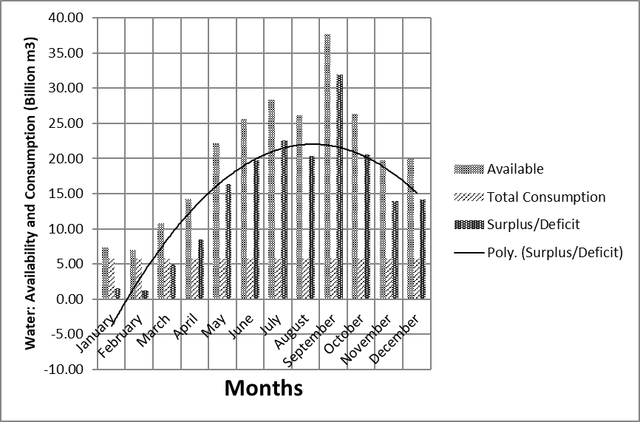

Figure 5: Water Status in Thailand by Month

The concern is now how to improve the capacity to manage water potential to a maximum possible level to keep up with the increasing water demand over time. An effective water management would be able to solve two water-associated problems at once, i.e. droughts and flooding problems. The possible constraints for Thailand in improving the capacity of water management do not come from the Thailand’s technological know-how and human resources, rather the geographical constraints to increase the capacity of controlled quantity of water, possible water conservation, particularly groundwater exploration as the abstraction of groundwater potential is currently not at full capacity. It also shows from the occasional exploration of conjunctive use of groundwater and surface water for agriculture purposes, and another essential factor is perhaps current financial capacity of the government, although this is a generic problem for most developing countries.
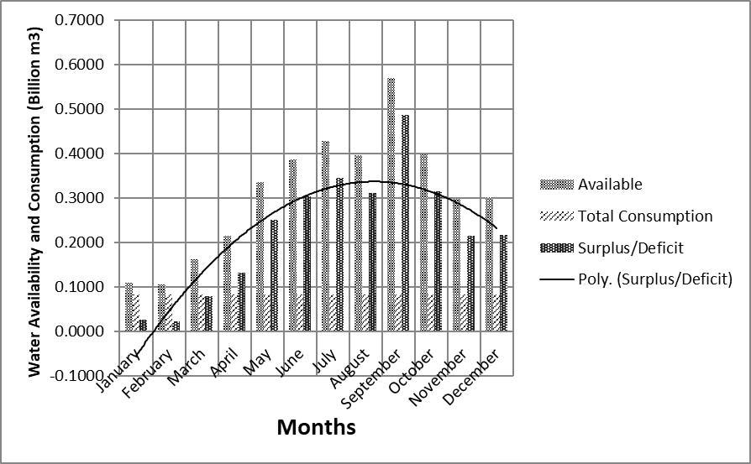

Figure 6: Water Status in Bangkok Metropolitan Region by month

In water sector, the dependency on the financial capacity of the government is very large since the only small portion of water-associated business can be commercialized, as the social function of water in a country with only to some degrees of total liberal economic system do exist like in Thailand. Section 6, Chapter 1 of the Water Resources Act (2018) addresses that the state is the property rights holder of the water resources and it must be used for the maximum interests of people. This is a clear message that water should not be in a total commercialization without at all ignoring the social function of the water. It is well understood as the water price set by PWA and MWA is reasonably low in comparison to fully commercial water price, as previously discussed.

4.5 Sensitivity Analysis of the Water Security in BMR

Analysis to which extent the water security in BMR will be crucial, i.e. the water deficit most likely happens, has been undertaken. An analysis is shown in Table 3.

Table 3: Sensitivity Analysis of the Water Security in BMR

Scenarios |  | Results
Supply side | Demand side
No change as of present supply capacity | - ↑ 3% annually in 10 years  - ↑ 5% annually in 10 years | Water deficit in January-February
No change as per present supply capacity | - ↑ 3% annually in 20 years  - ↑ 5% annually in 20 years | Water deficit in January-April
No change as per present supply capacity | ↑ 3% annually in 50 years | Water deficit January-May, November-December
↑ 5% constant (for the whole period) | ↑ 5% annually in 50 years | Water deficit whole year
Table 3 shows different scenarios of the supply and demand sides. It shows that for some moderate scenarios, the BMR water security is most likely “safe”. However, the most risky situation in BMR, according to the sensitivity analysis, is that when the capacity of the supply i.e. water availability increases only 5% at any time during the period, meanwhile the demand increases by 5% annually during 50 years period, the BMR will be in a totally bleak situation with respect to the water crisis.

Since the demand cannot be stopped increasing, the only way to cope with water security issues in Bangkok Metropolitan Region is by increasing the water availability i.e. increasing the capacity of water treatment and water management twenty percent in ten years. The surface water potential in Thailand and Bangkok Metropolitan Region is large and left unutilized, and the construction of large reservoirs is not possible because of geographical condition, environmental impacts and resistances from the pressure groups, the environmental watchdogs, it is advisable that construction of field reservoirs across the country, and construction of underground reservoirs in the BMR are to be deliberated to ensure that water security in Thailand and BMR is handled appropriately.

5. Conclusions and Way Forward

We examined water security based on three essential factors that significantly affect the water price and water management in Bangkok Metropolitan Region, based on 1983-2016 data. Analysis shows that, despite possibilities of water scarcity during the months of January to March, there is essentially water security issue for the rest of the year - both in Thailand and the Bangkok Metropolitan Region, since water availability and water potential in the region is much greater than current consumption. Some moderate scenarios e.g. achievable by plan also show the confidence of water security in BMR. However, sensitivity analysis on more extreme scenarios shows the possibility of water shortage in Bangkok Metropolitan Region. Deliberation on this matter is required at the earliest possible opportunity to cope with this possible threat.

Within three elements of the water security i.e. water-pricing policy, social function of water and threats to water resources, the study asserts that the trilemma leads to the dilemma of water-pricing policy and threats to water resources vis-à-vis the social function of water, in which the social function of the water would likely to prevail because of the strong support from the Water Resources Act 2018. With this strong support, along with the sufficient financial support from the government on the construction of necessary infrastructure to improve the water supply, the water security issues in Thailand and BMR could be managed.

Acknowledgments

We thank the Department of Civil Engineering, School of Engineering, King Mongkut’s Institute of Technology Ladkrabang Bangkok, Thailand, KMITL Research and Innovation Services, and Faculty of Engineering of Universitas Sebelas Maret, Indonesia for supporting this work.

References

Albritton-Jonsson, F. (2012). The industrial revolution in the Anthropocene. The Journal of Modern History, 84(3), 679-696.

Aschner, M., Paoliello, M. M., Tsatsakis, A., Bowman, A. B., Dorea, J. G., Hartung, T., ... & Barbosa Jr, F. (2021). Social injustice in environmental health: A call for fortitude. Environmental research, 194, 110675.

Baer, H. A. (2012). Global capitalism and climate change. In Handbook on International Political Economy (pp. 395-414).

Bonnal, J. (2003). The sociological approach in watershed management: from participation to decentralization. Proceedings of African Regional Workshop on Watershed Management. Nairobi, Kenya, 8-10 October 2003.

Carr, J. A., Seekell, D. A., & D’Odorico, P. (2015). Inequality or injustice in water use for food?. Environmental Research Letters, 10(2), 024013.

Collins, T. W., & Bolin, B. (2007). Characterizing vulnerability to water scarcity: the case of a groundwater-dependent, rapidly urbanizing region. Environmental Hazards, 7(4), 399-418.

Cook, C., & Bakker, K. (2012). Water security: Debating an emerging paradigm. Global environmental change, 22(1), 94-102.

Eekhout, J. P., Hunink, J. E., Terink, W., & Vente, J. D. (2018). Why increased extreme precipitation under climate change negatively affects water security. Hydrology and Earth System Sciences, 22(11), 5935-5946.

Cosgrove, W. J., & Loucks, D. P. (2015). Water management: Current and future challenges and research directions. Water Resources Research, 51(6), 4823-4839.

EIC (2016). Thailand’s drought crisis 2016: Understanding it without the panic. Economic Intelligence Center, Siam Commercial Bank. Assessed 11 June 2020 https://www.scbeic.com/en/detail/product/2127

Engle, N. L., Johns, O. R., Lemos, M. C., & Nelson, D. R. (2011). Integrated and adaptive management of water resources: tensions, legacies, and the next best thing. Ecology and society, 16(1).

European Environment Information and Observation Network, Eionet (2018). Climate impacts on water resources. Retrieved from https://www.eea.europa.eu/archived/archived-content-water-topic/water-resources/climate-impacts-on-water-resources Last accessed 3 March 2020.

Framingham, Charles F.; Stoecker, Arthur L.; Khatikarn, Kanok; Sriplung, Somnuk; and Heady, Earl O., "Agricultural Development Planning in Thailand: Some Supporting Analysis" (1977). DAE-CARD Sector Analysis Series. 1. http://lib.dr.iastate.edu/dae-card_sectoranalysis/1

Ghose T. (2015). Why is water so essential for life? LiveScience. Retrieved from https://www.livescience.com/52332-why-is-water-needed-for-life.html Last accessed 16 June 2021.

Giordano, M., & Shah, T. (2014). From IWRM back to integrated water resources management. International Journal of Water Resources Development, 30(3), 364-376.

He, W. J., Lai, Y. S., Karmacharya, B. M., Dai, B. F., Hao, Y. T., & Xu, D. R. (2018). Geographical heterogeneity and inequality of access to improved drinking water supply and sanitation in Nepal. International journal for equity in health, 17(1), 1-14.
Hirmas, D. R., Giménez, D., Nemes, A., Kerry, R., Brunsell, N. A., & Wilson, C. J. (2018). Climate-induced changes in continental-scale soil macroporosity may intensify water cycle. Nature, 561(7721), 100-103.

Iglesias, A., Garrote, L., Flores, F., & Moneo, M. (2007). Challenges to manage the risk of water scarcity and climate change in the Mediterranean. Water resources management, 21(5), 775-788.

Jiang, Y. (2015). China's water security: current status, emerging challenges and future prospects. Environmental Science & Policy, 54, 106-125.

Kisakye, V., & Van der Bruggen, B. (2018). Effects of climate change on water savings and water security from rainwater harvesting systems. Resources, Conservation and Recycling, 138, 49-63.

Mancosu, N., Snyder, R. L., Kyriakakis, G., & Spano, D. (2015). Water scarcity and future challenges for food production. Water, 7(3), 975-992.

Manorom, K (2020). NGOs and civil society in Thailand. P. Chachavalpongpun (ed.). Routledge Handbook of Contemporary Thailand.

McIntyre-Mills, J. (2018, June). Cascading risks of climate change on water security and the potential for rapid adaptation. In Proceedings of the 62nd Annual Meeting of the ISSS-2018 Corvallis, OR, USA (Vol. 1, No. 1).

Mekonnen, D. Z. (2010). The Nile Basin cooperative framework agreement negotiations and the adoption of a ‘water security’paradigm: flight into obscurity or a logical cul-de-sac?. European Journal of International Law, 21(2), 421-440.

Misaghi, F., Delgosha, F., Razzaghmanesh, M., & Myers, B. (2017). Introducing a water quality index for assessing water for irrigation purposes: A case study of the Ghezel Ozan River. Science of the Total Environment, 589, 107-116.

Molle, F., Chompadit, C., & Keawkulaya, J. (2000, December). Dry-season water allocation in the Chao Phraya basin: what is at stake and how to gain in efficiency and equity. In Proceedings of the International Conference The Chao Phraya Delta: historical development, dynamics and challenges of Thailand's rice bowl (pp. 12-15).

NNT (2019). Drought disaster initial damage estimated 10bn Baht. Retrieved on 11 June 2020 at https://thainews.prd.go.th/en/news/detail/TCATG190803115612736

Penn, H. J., Loring, P. A., & Schnabel, W. E. (2017). Diagnosing water security in the rural North with an environmental security framework. Journal of environmental management, 199, 91-98.

Pereira, L. S., Cordery, I., & Iacovides, I. (2009). Coping with water scarcity: Addressing the challenges. Springer Science & Business Media.

Royal Thai Dept of Disaster Prevention and Mitigation (2015). National Disaster Risk Management Plan.

Van Beek, L. P. H., Wada, Y., & Bierkens, M. F. (2011). Global monthly water stress: 1. Water balance and water availability. Water Resources Research, 47(7).

Waterfootprint (2019). The impacts of climate change on water resources. Retrieved from https://www.watercalculator.org/footprint/climate-change-water-resources/ Last accessed 3 March 2020.

Westall, F., & Brack, A. (2018). The importance of water for life. Space Science Reviews, 214(2), 1-23.

Zeitoun, M., Lankford, B., Krueger, T., Forsyth, T., Carter, R., Hoekstra, A. Y., ... & Matthews, N. (2016). Reductionist and integrative research approaches to complex water security policy challenges. Global Environmental Change, 39, 143-154.

The price of bottled mineral water is THB 8 per 0.5 deci-m³ (including packaging), or about THB 12 per deci-m³ or USD 380/m³. Assuming the comparable water quality of both, in reality the quality of water is different, still the price of USD 0.5 per m³ (government’s price) and USD 380 per m³ (profit-oriented company’s price) is reasonably incomparable.

